NPC Design

### Normal Enemies

#### Melee_1

**Description:** normal enemy melee fighters, nothing special.

**Health**: medium

**Attack:** medium

**Movement Speed**: medium

**Attack Speed:** medium

**Attack Range**: low

**Moves:**

Normal Melee attack

**Difficulty:** low

#### Ranged_1

**Description:** normal enemy using ranged attacks.

**Health**: medium

**Attack:** medium

**Movement Speed**: medium

**Attack Speed:** medium

**Attack Range**: high

**Moves:**

Normal ranged attack

**Difficulty:** low

#### Melee_2

**Description:** shielded enemy, using swords and shields

**Health**: medium

**Attack:** medium

**Movement Speed**: medium

**Attack Speed:** medium

**Attack Range**: low

**Moves:**

-Normal melee attack

-shield up: movement speed ↓，damage taken ↓↓, can’t attack

-shield down: back to normal status

**Difficulty:** medium

#### Ranged_2

**Description:** stealth enemy using medium-ranged projectiles

**Health**: low

**Attack:** medium

**Movement Speed**: high

**Attack Speed:** high

**Attack Range**: medium

**Moves:**

-cannot attack normally

-stealth: disappear->appear behind player at a moderate distance->attack player

**Difficulty:** medium

#### Melee_3

**Description:** heavy shielded enemy, high health, slow movement, no attack

**Health**: high

**Attack:** N/A

**Movement Speed**: low

**Attack Speed:** N/A

**Attack Range**: low

**Moves:**

-block certain places

**Difficulty:** medium

#### Melee_4

**Description:** melee enemy using whip-like weapon

**Health**: medium

**Attack:** medium

**Movement Speed**: medium

**Attack Speed:** high

**Attack Range**: medium

**Moves:**

-normal attack: attack the opposite side of player: 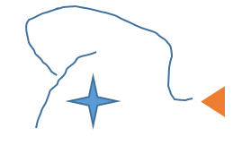

**Difficulty:** medium

### Bosses

#### Boss_1

**Scene:**

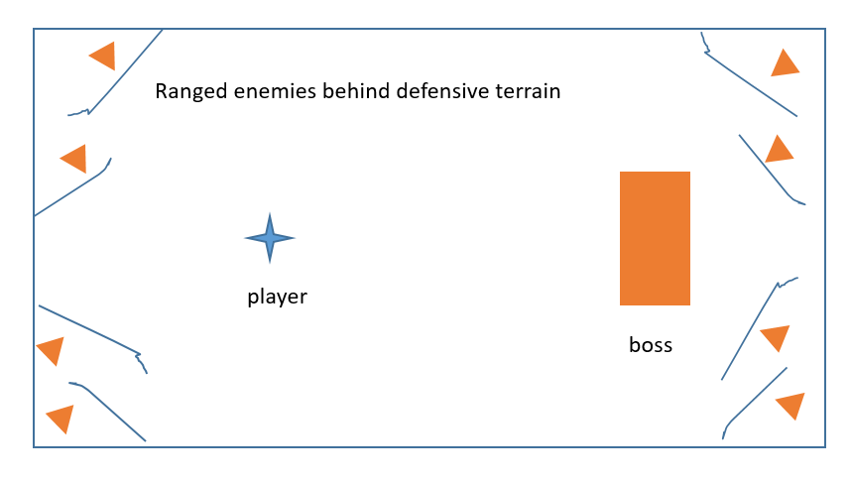

**Description:** heavy shielded boss, high health, slow movement, high defense from front.

**Movement Speed**: low

**Moves:**

-melee attack: normal melee attack with knockback effect. Hard to block

Attack: medium

Attack Speed: low

Attack Range: medium

-dash: boss dash toward to player, stop when hit player or border of the map. cannot be blocked. Boss stuns for a while after stop.

Attack: medium

Attack Speed: N/A

Attack Range: special

**Other enemies:** several ranged_1

### Friendly NPCs

TBD